PRODUCT DETAILS

**Casio Watch GA-2000SU-1AER**

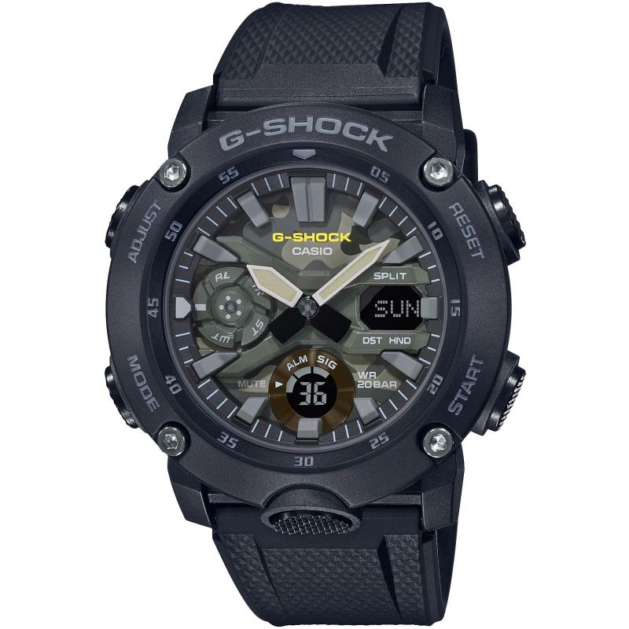

**£129.00**

**Specifications**

**Brand**: Casio

**Alarm**: Yes

**Analogue/Digital**: Analogue

**Backlight**: Yes

**Case depth approx**.: 14.00mm

**Primary Material**: Plastic/Resin

**Case Shape**: Circle

**Case width approx**.: 49.00mm

**Chronograph**: Yes

**Clasp type**: Strap buckle

**Dial Colour**: MultiColour

**Multiple Time Zones Display**: World Time

**Gender**: Unisex

**Glass**: Mineral

**Model Name**: G-Shock

**Movement Source**: Japan

**Movement**: Quartz

**Strap colour**: Black

**Strap Type**: Plastic/Resin Bracelet

**Water Resistance**: 200 metres

**Weight (g):** 64.00

**BARCODE**: 4549526258930

**Guarantee**: 2 years

**Country of Origin** **Code**: TH